Newsletter No. 010
Securities and Futures Bureau
Financial Supervisory Commission, Executive Yuan

I. News and Events
(1) 2005 IOSCO Emerging Markets Regional Training Seminar
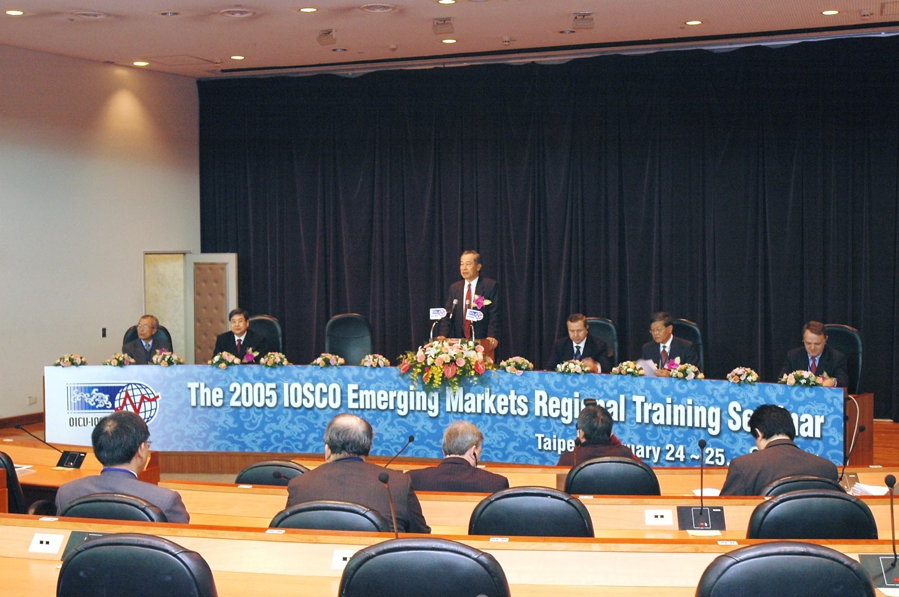
The two-day 2005 IOSCO Emerging Markets Regional Training Seminar was held at the Howard International House on 24-25 February 2005. The event, aimed at raising the international profile of Taiwan’s securities markets, was hosted by the Financial Supervisory Commission with the assistance of the International Organization of Securities Commissions (IOSCO) General Secretariat. The seminar focused on two main topics in international emerging markets: corporate governance and investor protection. It featured numerous keynote speakers, panel discussions, and general meetings.
The moderators, panelists, and speakers included many internationally renowned practitioners, officials, and scholars. Among those flying in for the seminar from overseas were Dr. Dogan Cansizlar, Chairman of the Capital Markets Board of Turkey, Dr. Andrew L.T. Sheng, Chairman of the Securities and Futures Commission of Hong Kong, Stephen P. Harbeck, President and CEO of the U.S. Securities Investor Protection Corporation, and senior officials of the U.S. Securities and Exchange Commission. Seminar faculty from Taiwan included Dr. Sheng-Cheng Hu, Chairperson of the Council for Economic Planning and Development, Jaw-Sheng Kong, Chairperson of the Financial Supervisory Commission, Daniel Tsai, Chairman of Fubon Financial Holding, and Nita Ing, Chairwoman of the Taiwan High Speed Rail Corp.
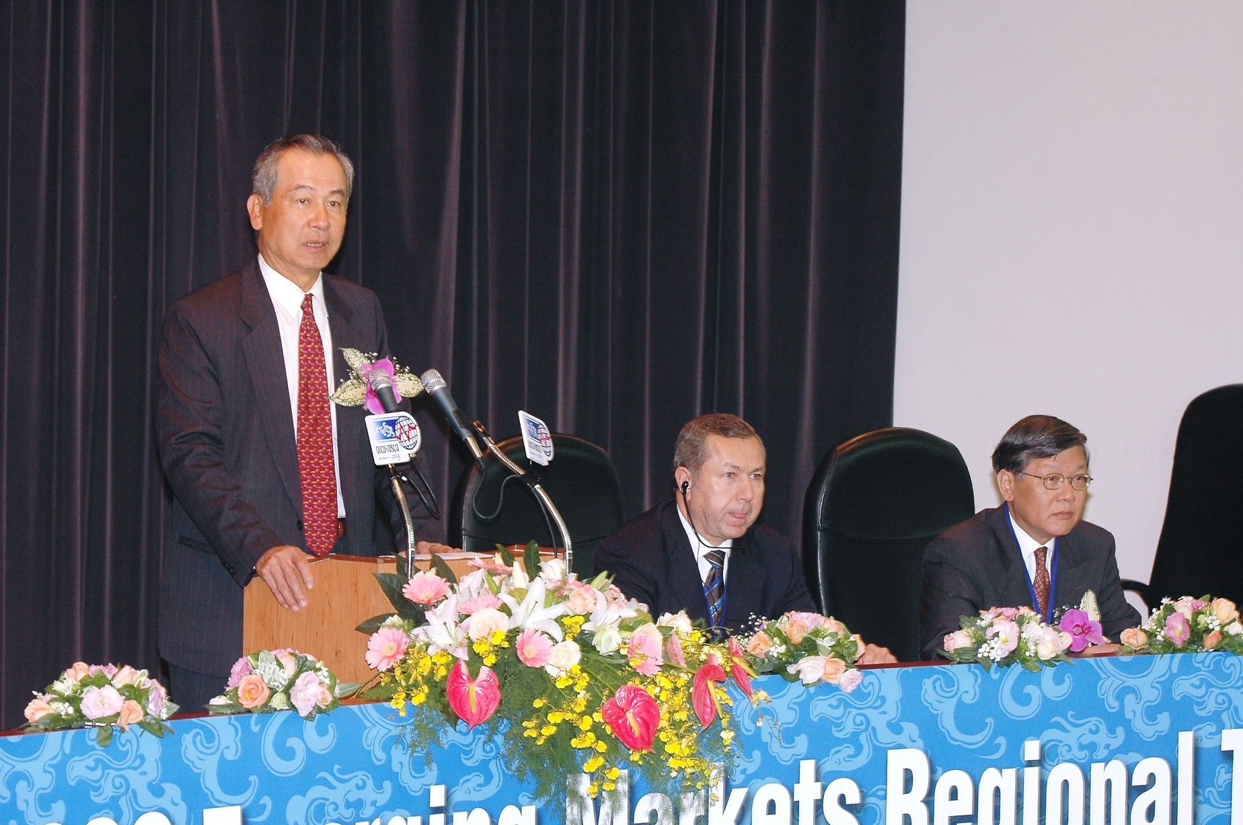
The participants in this year’s training seminar comprised some 60 middle-to-senior management officials of financial market regulators or self-regulatory organizations of over 20 countries including the United States, Singapore, and Turkey. Among them were many top or senior regulatory officials, including Dimana Rankova, Deputy Chairperson of the Bulgarian Financial Supervision Commission, Abdulla Al Turifi, Chief Executive of the Emirates Securities and Commodities Authority, Rentsen Sodkhuu, Chairman of the Mongolian Stock Exchange, and Dhammika Perera, Executive Director of the Bombay Stock Exchange.

(2) Adjustments to the Block Trading System
A number of adjustments to the block trading system will be implemented from 4 April 2005. The adjustments are aimed at enhancing block trading functions and raising the willingness of large position traders to use block trading procedures, reducing the impact of block trades on ordinary trade prices, facilitating block account transfers between block traders, and meeting trading needs related to exchange-traded funds.
The following are among the key adjustments to the block trading system:
- Trading hours are expanded to include three periods: intra-day from 9:30 to 9:40 and 11:30 to 11:40 a.m. and off-hours from 1:35 to 1:50.
- Trade price flexibility is increased to a maximum 2 percent above or below the reference price.
- The applicable scope of block trading is expanded: the minimum order quantity is 500,000 shares or NT$15 million per single stock buy or sell trade, or 5 stocks and NT$15 million per basket buy or sell trade.
- Trading efficiency is increased: the securities firm pre-collects the securities and funds, reports them to the stock exchange by computer, and trades are then settled by same-day real-time gross settlement.

(3) Investment Trust Enterprises Permitted to Offer Principal Protected Funds
To allow securities investment trust enterprises to issue principal protected funds, relevant amendments have been made to Articles 44 and 45 of the Regulation Governing Securities Investment Trust Funds, and Articles 6 and 13 of the Regulation Governing Information to be Included in Prospectuses by Securities Investment Trust Enterprises Offering Securities Investment Trust Funds.

(4) Restrictions Relaxed for Investment in Hong Kong H-Shares and Red Chips by Offshore Funds With Permission to Engage in Securities Recommendation and Consulting Business
In response to changes in the weightings of H-shares and red chips in the MSCI and FTSE indices, the limit on the amount that offshore investment funds are allowed to invest in H-shares and red chips has been raised from 5 percent of their assets to 10 percent from 31 January 2005.

(5) Strip Bond Trading System Launched
In bond stripping, a coupon bond is stripped into two separate bonds, one referred to as the “interest only” (IO) portion and the other as the “principal only” (PO) portion. After stripping, the PO and the IO can be traded separately on the secondary market. This will enable small investors to participate directly in the bond market, and also will be a key element in the future development of principal protected funds by domestic investment trust enterprises and future innovations in structured products by the financial industry.

II. Market Wrap-up
As of the end of February, 700 companies were listed on the Taiwan Stock Exchange, an increase of one over the previous month. The total capital issued was NT$5,063.88 billion, an increase of NT$12.22 billion over the preceding month, and the market capitalization was NT$14,252.77 billion, an increase of NT$519.7 billion over the preceding month.
As of the end of February, 471 companies were listed on the GreTai Securities Market, no change against the previous month. The total capital issued was NT$626.10 billion, an increase of NT$1.37 billion over the preceding month, and the market capitalization was NT$1,195.12 billion, an increase of NT$69.73 billion over the previous month.
In February, the trading value of shares on the Taiwan Stock Exchange was NT$1,119.12 billion, a decrease of NT$35.96 billion against January, while the trading volume was 42.1 billion, a decrease of 7.66 billion shares compared with January.
As of the end of February, the accumulated net inward remittance of foreign investors was US$85.4 billion, an increase of US$3.8 billion over January. There are currently 147 securities firms, 23 futures commission merchants, 45 securities investment trust enterprises and 219 securities investment consulting enterprises.

