News and Events

- Foreign nationals without domicile in Taiwan are allowed to borrow from financial institutions
  - As of November 15, 2006, the FSC has allowed offshore overseas Chinese and foreign nationals investing in Taiwan securities to have New Taiwan Dollar loans from domestic financial institutions exempted from the restrictions of Article 21, subparagraph 3 of the Regulations Governing Investment in Securities by Overseas Chinese and Foreign Nationals that would otherwise prohibit them from extending loans or providing collateral. Their custodian institutions must record the information required by Article 22 of those Regulations and report it to the FSC and the Department of Foreign Exchange of the Central Bank of China within ten days after the end of each month.
  - The daily information on cash borrowing or intraday credit arrangements of offshore overseas Chinese or foreign nationals at domestic financial institutions and their financing arrangements at securities firms or securities finance enterprises shall be reported by fax by their custodian banks to the Securities and Futures Bureau of the FSC and the Department of Foreign Exchange of the Central Bank of China on the following trading day.

- Regulations on securities firms operating securities lending business
  - The FSC on October 31, 2006 issued a regulation that when a securities firm lends securities other than book-entry central government bonds to a client for sale, or when transferring such securities to its dealing division for sale, the above-mentioned selling price may not be lower than the closing price of the previous trading day. However, this restriction does not apply to lending or transferring securities for sale with beneficiary certificate of exchange-traded funds or the aforesaid securities to its dealing division for selling the underlying securities for hedge purpose on put warrants or a short hedge on structured product transactions.
  - The FSC also reaffirmed on October 27, 2006 that a securities firm may not solicit, broker, promote, or accept orders for trades of securities of the mainland China area or of securities issued in Hong Kong by government or company of the mainland area.

- Scope of subject futures dealers and trading amounts of foreign futures are enlarged
On October 18, 2006 the FSC allowed foreign futures dealers with exclusive futures business as well as domestic and foreign securities firms who concurrently operate futures trading to engage in trading of foreign futures, and loosened restrictions on the trading amounts. Restrictions were eased as follows:
  - The scope of subject futures dealers has been extended from the current domestic futures dealers with exclusive futures business to foreign futures dealers of the same type, as well as domestic and foreign securities firms who concurrently operate futures trading. All the aforesaid subject enterprises can trade with futures offered by foreign exchanges pursuant to Article 5 of the Futures Trading Act.
  - Trading limits have been reset at 30% of the lower of either the paid-in capital or the net worth of futures entities (for securities firms concurrently dealing with futures trading, the working capital specially allocated for futures division will be deemed their paid-in capital; for foreign futures dealers with exclusive futures business, the capital specially allocated for operations within the ROC will be deemed their paid-in capital). Besides, a new provision limits the futures trading amounts on any single exchange to 10% of the lower of their paid-in capital or net worth.
  - In consideration of the fact that some futures entities will need to engage in hedging of foreign futures trading (such as Gold Futures) for market making, a new provision stipulates that "futures entities with the approval of the FSC" may be exempted from the 30% limit.

- FSC attended 2006 IOSCO Technical Committee Conference
Wu Tang-Chieh, Director General of the Securities and Futures Bureau of the FSC, led a Taiwanese delegation of members of the Taiwan Stock Exchange, GreTai Securities Market, and Taiwan Futures Exchange to attend the IOSCO (International Organization of Securities Commissions) Technical Committee Conference convened from November 15 to 17, 2006 in London. The focus of the aforesaid conference this year includes topics of how to establish uniform standards or principles with respect to the activities of international funds, the cross-border Trading System, market intermediaries (securities firms), enforcement in cross-border cooperation, and accounting and auditing as securities markets face ever-increasing global integration trend. In addition to keeping up with the latest developments in global market supervisions, the delegation took advantage of the conference for interaction with the attendees to enhance those members’ awareness of Taiwan's securities and futures markets.
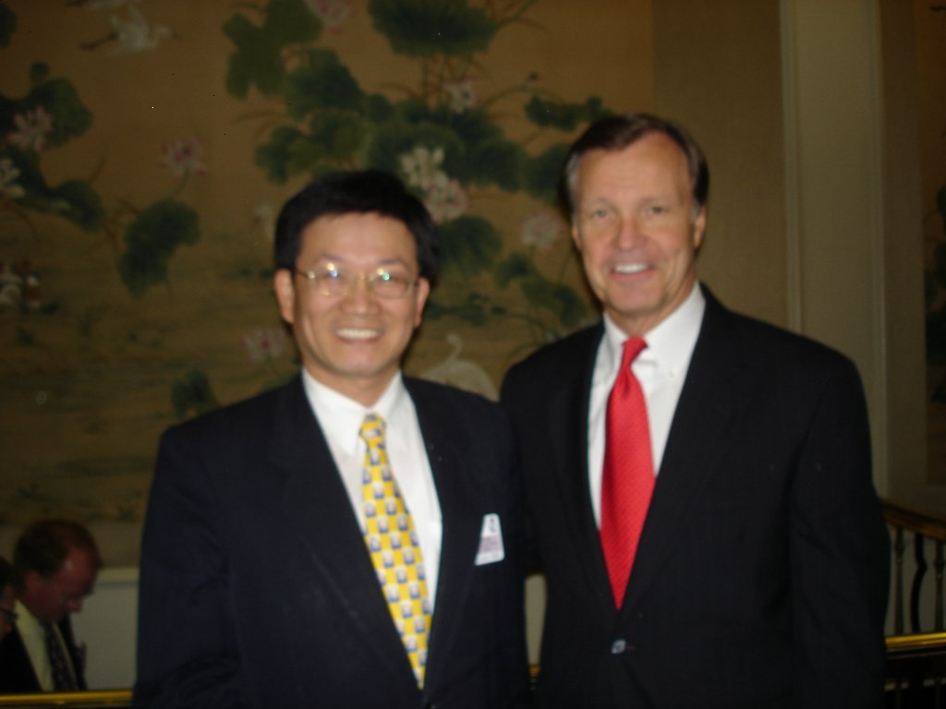
Wu Tang-Chieh, Director General of the FSC Securities and Futures Bureau, with Mr. Christopher Cox, Chairman of the US Securities and Exchange Commission
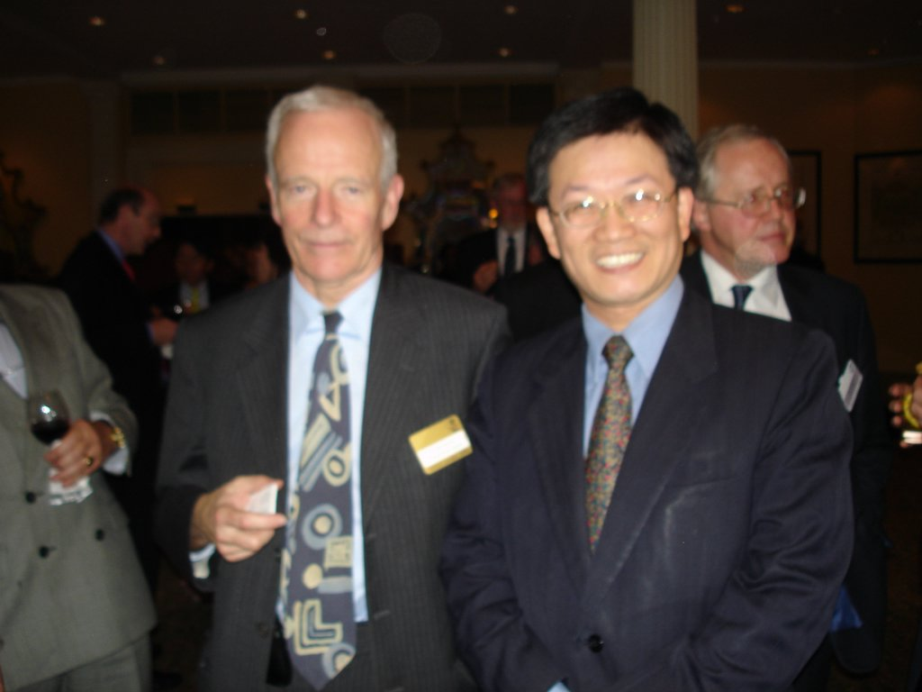
Wu Tang-Chieh, Director General of the FSC Securities and Futures Bureau, with Sir. Callum McCarthy, Chairman of the UK Financial Services Authority

- Information on the prosecution of major securities law violations and related judgments is provided with English and Chinese versions at the website of the Securities and Futures Bureau of the Financial Supervisory Commission, Executive Yuan: http://www.sfb.gov.tw/intro_index.asp

