Newsletter No. 006
Securities and Futures Bureau
Financial Supervisory Commission, Executive Yuan

I. News and Events

(1) Chairperson Jaw-Sheng Kong led a delegation to attend High-Level Conference by IOSCO Technical Committee in New York

Chairperson Jaw-Sheng Kong, of Financial Supervisory Commission (FSC), Executive Yuan, led a delegation to attend the High-Level Conference organized by IOSCO Technical Committee in New York on October 22, 2004.

IOSCO is the world largest organization of securities regulatory bodies, composed of securities supervisory authorities of more than 100 countries. IOSCO Technical Committee has 15 members coming from the supervisory bodies of developed markets, i.e. USA, British, and Germany. In Asia, only Japan, Hong Kong, and Australia are members of the Technical Committee. Even though Taiwan’s FSC is not a member of the Technical Committee, yet the FSC was invited by U.S. SEC to participate in the Conference for interchanging opinions on the most concerned topics with the decision-makers of the advanced securities markets.

In addition to the officials of FSC, Mr. Nai-Jen Wu (Chairman of Taiwan Stock Exchange), and Mr. Hung-wen Chien (Chairman of Taiwan Securities Association) also joined the delegation. The attendees to the Conference include Mr. William H. Donaldson (Chairman of US SEC), Mr. Arthur Levitt and Mr. Richard Breeden (both former Chairman of US SEC), Mr. John Thain (CEO of NYSE), Mr. John Tiner(Chief Executive of the British FSA), Mr. Charles Prince (Chief Executive of Citigroup), Mr. Eliot Spitzer (Attorney General, New York State), Mr. Rudolph W. Giuliani (former mayor of New York city). This conference functions as a communication channel for the representatives of the regulatory bodies of advanced markets, also led an interactive platform for bilateral meetings of top securities regulators over many issues.

(2) Dr. Rebecca Chung-Fern Wu delivered a speech in “The 6th Asia Corporate Governance Roundtable” held by OECD

Dr. Rebecca Chung-Fern Wu, Commissioner of the FSC, Executive Yuan, was invited by the Organization for Economic Co-operation and Development (OECD) to deliver a speech in “The 6th Asian Corporate Governance | 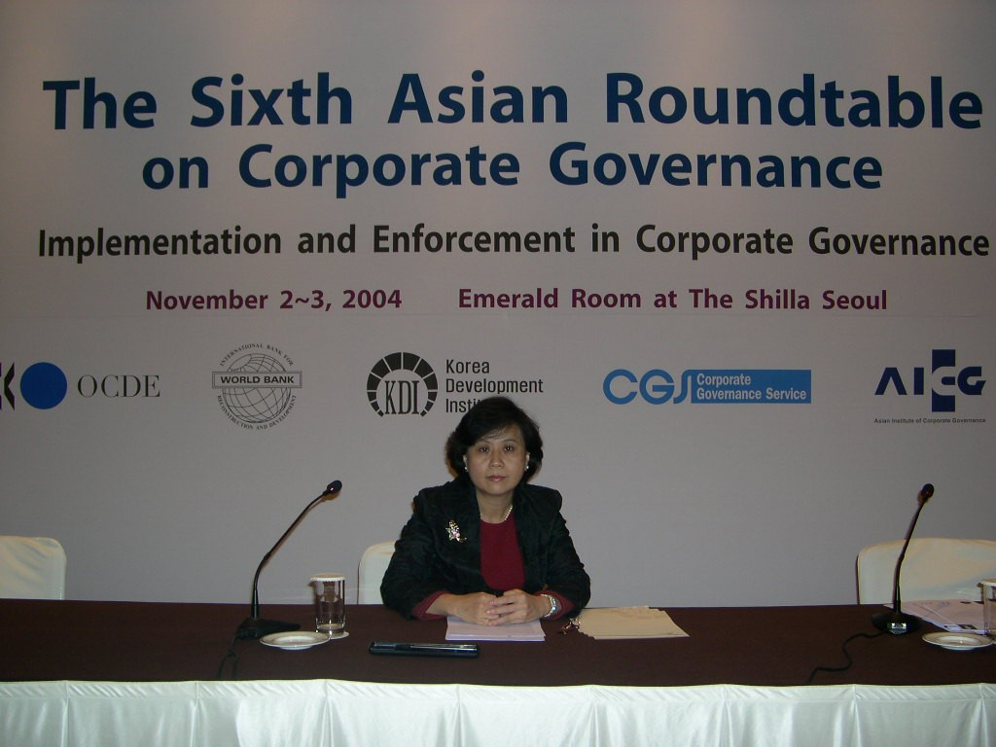
Roundtable” in Seoul on November 2, 2004. Other invited speakers include Mr. Kiyo Akasaka (Deputy Secretary General, OECD), Mr. Byong-Won Bahk (Deputy Minister of Finance and Economy, Korea), Mr. Roberto Ulissi (General Director, Ministry of Finance, Italy), Mr. Mats Issaksen (Head, Corporate Affairs Division, OECD), Mr. Louis Bouchez (Senior Corporate Governance Specialist, OECD), Mr. Hideki Kanda (Professor, University of Tokyo), Mr. Hasung Jang (Korea University), etc.

OECD, an international economic forum with members coming from industrialized countries, plays a very important role as an international economic and trade organization. After entering into WTO, Taiwan has applied to be the observer in the OECD Competitive Committee. OECD puts emphasis on the contribution of non-member in the participation of OECD activities for achieving the efficacy of “mutual benefits”. In addition to delivering a speech, Dr. Wu also explained to representatives of the operations of the Taiwan FSC, thus enhanced international visibility of domestic capital market.

(3) The 2nd Taipei Corporate Governance Forum( 2nd TAICGOF)

The FSC hosted “The 2nd Taipei Corporate Governance Forum” on November 5, 2004, focusing on the practical implementation of regulatory enforcement, competitiveness, family-owned enterprises in Asia, and international harmonization. The focus is a bit different from the prior one which was emphasizing on the promotion of corporate governance concepts and policy. The presence of Mr. Mats Isaksson, Senior Consultant and Head of Corporate Affairs Division, OECD, indicated a gesture of OECD’s regard towards this forum.
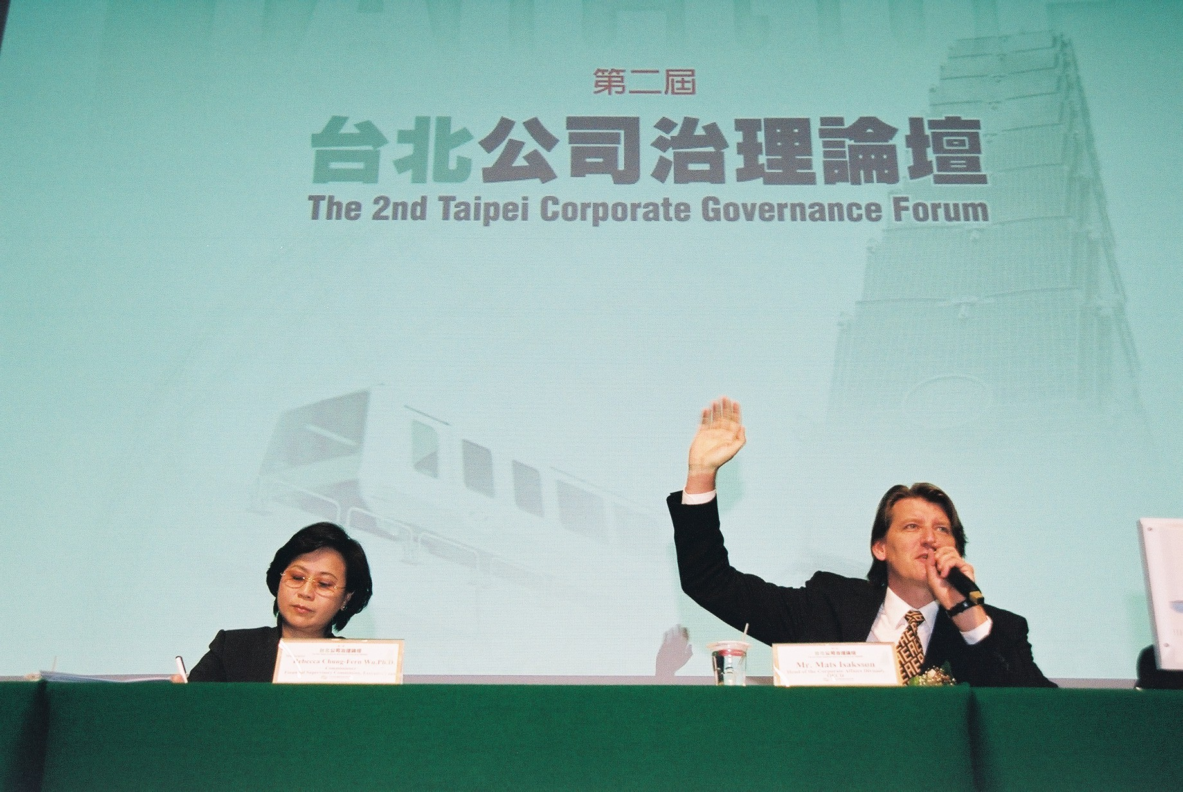
The Forum explores the agenda of five issues covering the viewpoints of international organization to the global promotion of corporate governance, the enhancement of enterprise’s competitiveness through corporate governance, the features of corporate governance in Asian corporations, the operations and regulatory enforcement of the boards, and the improvement and international harmonization of transparency of information disclosure. All of which aimed at future development of global corporate governance, and the way the domestic corporate governance links to international systems. The purpose of this forum is to promote domestic corporate governance to be in line with the international standards in the process of Taiwan capital market’s entry into developed market.

The speakers and panelists invited to the Forum are well-known experts domestically and internationally, and of great reputation in the different corporate governance related fields. In addition to Mr. Mats Isaksson, the speakers include Mr.Pat Barrett (Board member, IFAC), Mr. Edward K. F. Chow (Vice President, Hong Kong Institute of Certified Public Accountants), Dr. Hu, Sheng-Cheng (Chairperson, Council for Economic Planning and Development (CEPD), Executive Yuan), Dr. Paul S. C. Hsu (Chairperson, Chinese Management Association), Mr. Paul S. P. Hsu (Chairman and CEO, PHYCOS International Co., Ltd), Dr. Hasung Jang (Korea University), Dr. Joongi Kim (Yonsei University), Dr. Paul Sheard (Managing Director, Lehman Brothers Japan Inc. ), Mr. Peter Sutton (Head of Research, CLSA Taiwan), Dr. Rebecca Chung-Fern Wu (Commissioner, Financial Supervisory Commission, Executive Yuan), Dr. Syue-Ming Yu (Grand Justice, The Justice Yuan).

The number of attendees to the Forum exceeded 700, including directors and top executive officers from domestic listed companies, banking industry, securities industry, and insurance industry, and officials in charge of corporate governance affairs from all the organizations of Taiwan government, plus prominent academicians.
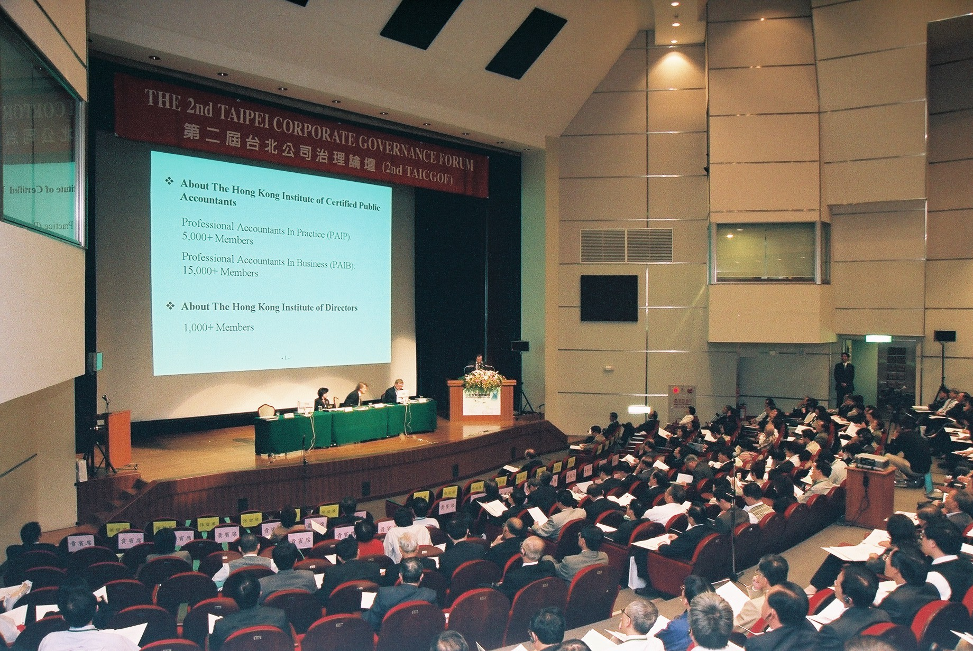

(4) Implementation of “Securities Investment Trust and Consulting Law”

In accommodation of the implementation of “Securities Investment Trust and Consulting law” on Nov. 11, 2004, the FSC, on October 30, promulgated the implementation of “Rules Governing the Establishment Criteria of Securities Investment Trust Enterprises”, “Rules Governing the Establishment Criteria of Securities Investment Consulting Enterprises”, “Rules Governing Securities Investment Trust Enterprises”, “Rules Governing Securities Investment Consulting Enterprises”, “Criteria Governing Securities Investment Trust Enterprises to Publicly Raise Securities Investment Trust Funds”, “Regulations Governing Securities Investment Trust Funds”, “Criteria Governing Information to be Published in Prospectuses for Securities Investment Trust Enterprises to Publicly Raise Securities Investment Trust Funds”, “Criteria Governing Information to be Published in Prospectuses for Securities Investment Trust Enterprises to Privately Raise Securities Investment Trust Funds”, “Guidelines Governing Meeting of Securities Investment Trust Fund Beneficiaries”, “Regulations Governing the Operation of Discretionary Investment Services by Securities Investment Consulting Enterprises and Securities Investment Trust Enterprises”, “Rules Governing Responsible Persons and Associated Persons of Securities Investment Trust Enterprises”, “Rules Governing Responsible Persons and Associated Persons of Securities Investment Consulting Enterprises”, “Regulations Governing the Selection of Non-member Directors and Supervisors of Securities Investment Trust & Consulting Association of R.O.C. ”, “Rules Governing Securities Investment Trust & Consulting Association of R.O.C.”, “Guidelines Governing Building Internal Control System in the Securities Investment trust Enterprises, and the Securities Investment Consulting Enterprises Operating Discretionary Investment Services for Clients”, and the revision of “Regulations Governing Book-Entry Operations for Centrally Deposited Securities”, which has been enforced since November 1, 2004.

(5) Stipulating “Best Practices for Managing Risk of Securities Firms”

To facilitate securities firms to build excellent risk management mechanism, the Securities and Futures Bureau has asked GreTai Securities Markets, Taiwan Stock Exchange, and Taiwan Securities Association to codify the “Best Practices for Managing Risk of Securities Firms”, that was approved on October 6.

(6) Allowing 5-day unlimited price variation for newly listed stocks

From March 1, 2005, the trading price of each newly listed stock on Taiwan Stock Exchange and GreTai Securities Market (GTSM) will be exempted from daily limit of 7% for the first five trading days. The measure is aimed to reflect market price of newly listed stocks, and draw the IPO prices of newly listed stocks close to their basic values.

(7) Shortening the minimum tick size in the securities market

To narrower tick size in securities trading is going to be in effect on March 1, 2005, for the purpose of lowering trading costs of investors and promoting stock price continuity.

(8) Increasing the varieties of margin collaterals for the stock options contracts

For increasing fund efficiency of futures traders in the trading of stock options contracts on October 8, in accordance with the Section 50(1) and 67 of the “Futures Trading law”, and Section 47(1) of “Rules Governing Futures Commission Merchants”, the SFB permitted the clearing bond that futures clearing house takes from its clearing members be in the form of underlying securities. Futures traders can use the underlying securities as margins when selling call options.

(9) Revision of “Standards Governing the Establishment of Futures Advisory Enterprises”and“Regulations Governing Futures Advisory Enterprises”

To meet the need that the securities brokerage firms and securities investment consulting enterprises are permitted to apply for engaging in futures consulting businesses concurrently, the Securities and Futures Bureau revised “Standards Governing the Establishment of Futures Advisory Enterprises” and “Regulations Governing Futures Advisory Enterprises” on October 20, 2004.

(10) Taiwan Stock Exchange hosted the Working Committee Meeting of East Asian and Oceanic Stock Exchanges Federation (EAOSEF)

Taiwan Stock Exchange hosted the Working Committee Meeting of East Asian and Oceanic Stock Exchanges Federation (EAOSEF) at Taipei on November 4, 2004, with the participation of 28 delegates from 12 member exchanges. The meeting is chaired by Dr. Nai-Kuan Huang, E.V.P. for Research & Development/ International Affairs. In addition to discussion of the regular organization affairs, the meeting had invited the representatives or guest speakers to make presentations on the topics of market information disclosure in trading period, technology sharing, legal protection and property rights of market data, corporate
governance in Hong Kong, integration
of Asian bond markets, and overview of Taiwan’s bond market.

(11) Taiwan Stock Exchange hosted the 2nd Asia/Oceania CCP Meeting

Taiwan Stock Exchange hosted the 2nd Asia/Oceania CCP Meeting at Taipei on November 3, 2004 with the participation of more than 20 representatives from 9 clearing organizations. The meeting was chaired by Ms. May Yu, S.V.P. for Clearing. The representatives have extensively inter-changed opinions concerning the future cooperation among clearing houses, promotion of CCP by the clearing houses, and sharing of clearing information. Ms. Mary Ann Callahan (Managing Director, Global Industry Initiatives, DTCC) and Junichi Shukuwa (Senior Advisor, International Division, UFJ Institute) were invited to make speech on the topics of “The Recent Development of DTCC” and “Development of Asian Bond Market” respectively.

(12) Book-Entry For Underlying Stocks of Equity Options As Margin Requirement

TSCD, on October 18 2004, commenced book-entry operation for the underlying stocks of equity options. This is to facilitate the business operation in Taiwan Futures Exchange (TAIFEX) that allows sellers of call options paying margins with the underlying stocks. As of the end of October, the number of underlying stocks of equity options transferred to the account of TAIFEX as margins has amounted to 2,236 thousand shares.

(13) Four Major Funds To Be Participants of TSCD

TSCD has approved to extend its participant list by including organizations that are in charge of managing the Public Servant Pension Fund, the Labor Pension Fund, the Labor Insurance Fund, postal savings or other governmental funds. This will allow these organizations to have a direct management of their investment portfolios as well as to strengthen audit and internal control. On November 1, 2004, the Managing Committee of the Public Servant Pension Fund has become a participant of TSCD.

II. Market Wrap-up

As of the end of October, 686 companies were listed on the Taiwan Stock Exchange, the same as the previous month. The total capital issued was NT$5,032.6 billion, an increase of NT$5.5 billion over the preceding month, and the market capitalization was NT$12,709.7 billion, a decrease of NT$157.2 billion against the preceding month.

As of the end of October, 456 companies were listed on the GreTai Securities Market, an increase of two over the previous month. The total capital issued was NT$629.9 billion, a decrease of NT$15.2 billion against the preceding month, and the market capitalization was NT$1,127.7 billion, an increase of NT$14.3 billion over the previous month.

In October, the trading value of shares on the Taiwan Stock Exchange was NT$1,637.2 billion, a decrease of NT$93.6 billion against September, while the trading volume was 71.5 billion shares, a decrease of 3.3 billion shares compared with September.

As of the end of October, the accumulated net inward remittance of foreign investors was US$75.1 billion, an increase of US$2.4 billion over September. There are currently 147 securities firms, 23 futures commission merchants, 45 securities investment trust enterprises and 217 securities investment consulting enterprises.

